Box-RICKdiculouslyEasy
- Scanning all the ports on the target IP address.
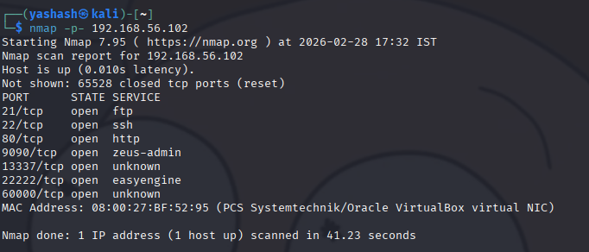

- Finding the flag(9090):
- nmap Ip address/24 ( /24 is subnet mask)
- we get the services that are present.
- copy the Ip address and search in url(ipaddr:9090). We get the flag for port 9090.
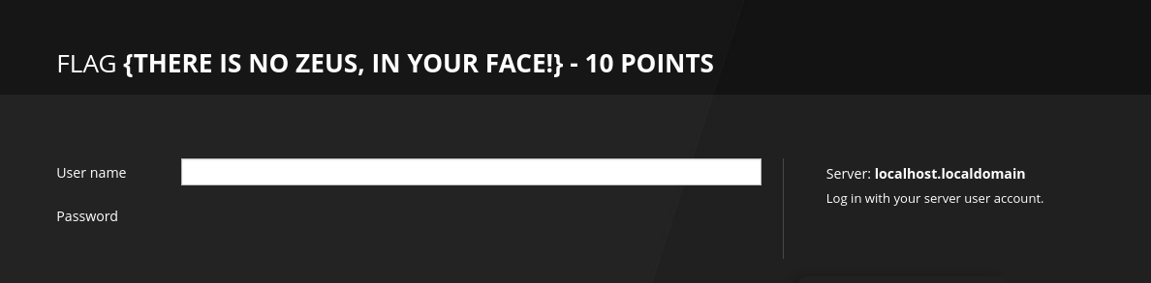
- Finding the flag(13337):
- since it is an unknown service we can try using “nc”.
- we found the flag for port 13337 .
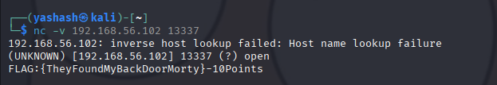
- Finding the flag(60000):
  - since it is also an unknown service we can try using “nc”.
  - Then we get something like # ….
  - Try something like “hi” then we received an output like command not found.
  - So that mean it acts as a terminal. So firstly lets check are there any files using “ls”.
  - There is file named (FLAG.txt) and just read the file and get the flag for port 60000
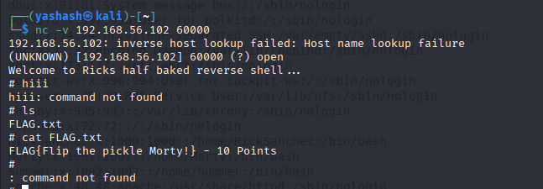
- Finding the flag(21):
  - Connect to ftp using the ip address.
  - We need to login using a user and pass. But here in this we can use “anonymous or ftp” as user name and password can be any text.
  - But this has limited permissions generally to read-only access to download public file.
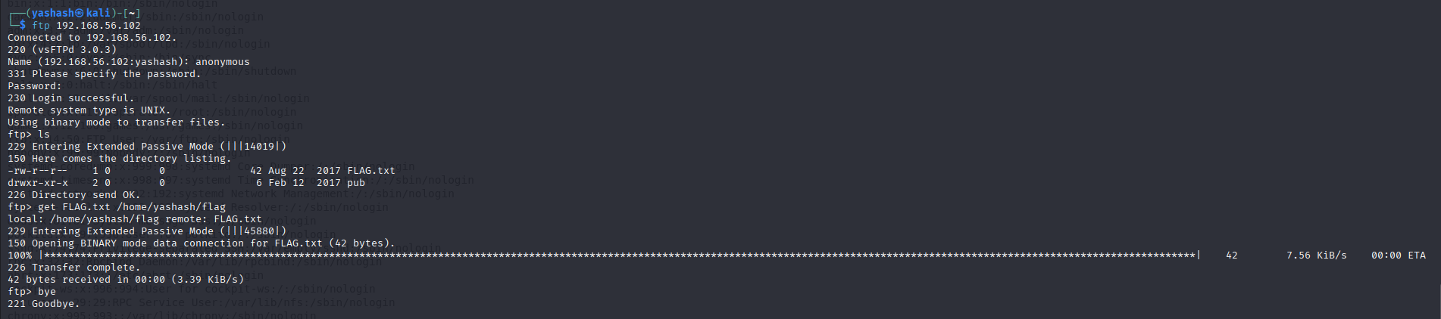
  - After successful log in just list the files that are present.
  - A file named FLAG.txt is available. But we can’t read it directly from the ftp terminal.
  - Because FTP is designed strictly for transferring files, not for execution or file manipulation on the server side.
  - So using “get” command transfer the file from that to our local terminal into a file.
  - The command is get filename ../../local.filename
  - Then read the file and get the flag for port 21
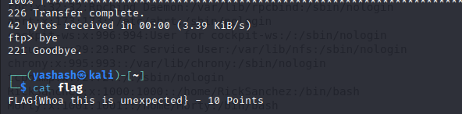

- The 3 users we found
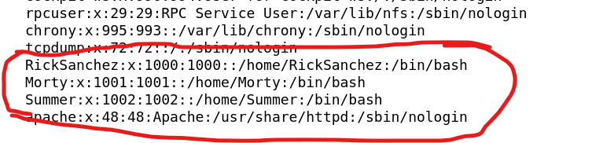
- Finding the flag(80):
    - Since we want more details of the Morty’s website in order to exploit it , to find the password.
    - We use "nikto” a web server vulnerability scanner to find the security misconfigurations, outdated software and dangerous files on web applications.
    - Run nikto -h hostname_or_ip
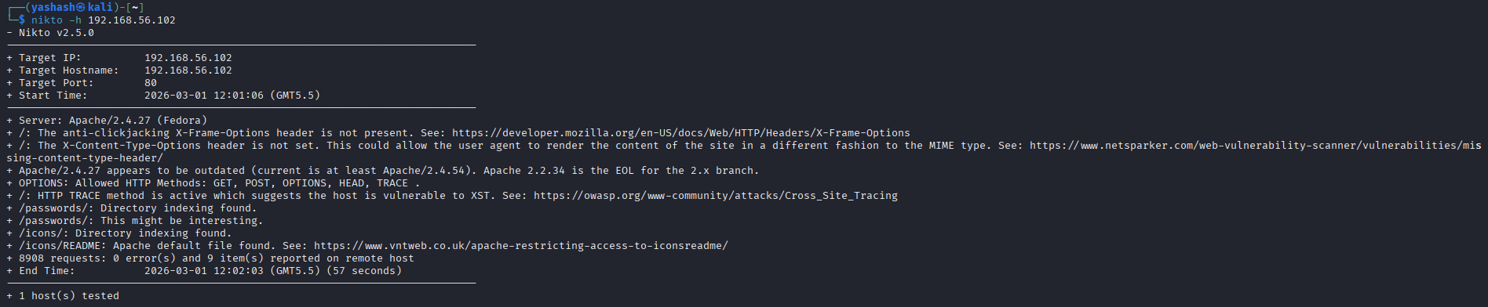
- We found a directory named passwords and then open it in the url.(192.168.56.102/passwords)
- A flag file is available and also password file.
- Click the password file and open the page source we get the password.(password=winter)
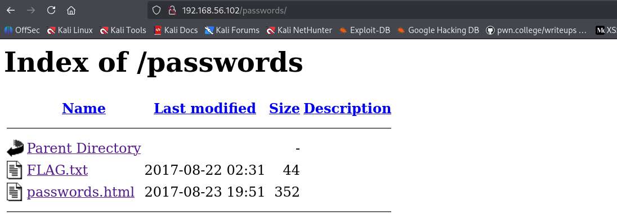
- The flag for the port 80
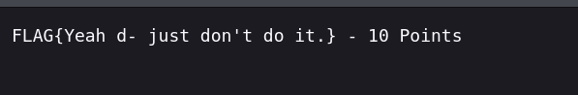
- Finding the flag(22222):
- We have three users and also a password. So only one user matches with the password.
- Run ssh -p 22222 Summer@192.168.56.102
- Enter the password. After log in run “ls” and FLAG.txt file is available.
- Get the flag for port 22222
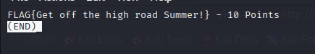
- Finding the flag(22222):
- Run ssh -p 22222 Summer@192.168.56.102
- Search for all the files ( ls / )
- In home directory we get three user names in the form of directories.
- Run cd Morty
- List the files and we see a password file in terms of jpg file.
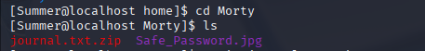
- Copy the file to local terminal by using the command.
- scp -P 22222 user@host:/path/to/file.jpg /path/to/local/directory
- here In ssh we use -p and in scp we use -P for ports.
- After that read the image file.
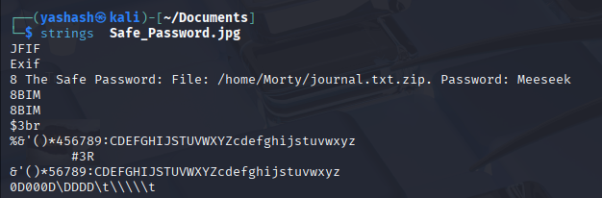
- Now lets copy the zip file to local terminal and extract it.
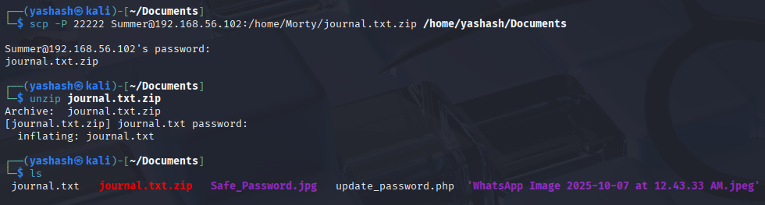
- Now read the file and get the flag.( cat journal.txt )

- Finding the flag(22222):
- Run ssh -p 22222 Summer@192.168.56.102
- Search for all the files ( ls / )
- Go to home directory and list the files we have FLAG.txt and safe file.
- In Before flag in that there is a clue in order to get the next flag.
- In the above clue it is said that Rick told me a huge secret about safe password like something either it is about safe or password. but however he gave me something.
- He gave a 131333 as a secret.
- When we run the ./safe it is said that next time tell rick to enter a argument in the command.(eg: ./safe hiii)
- If we look into the before flag the clue given and this we should understand that the command is given as a secret.
- Run ./safe 131333 and get the flag for port 22222
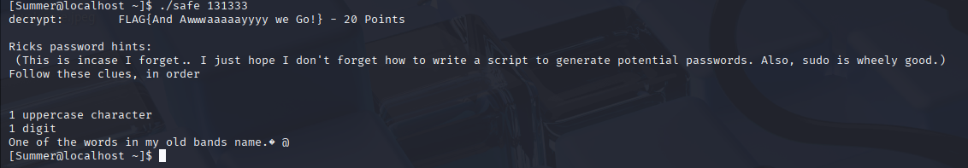

- Finding the password for Rick:
      - From the above flag we got some clues related to Rick password.
      - We know that 1st character is an uppercase and 2nd is a number from 0-9 and then followed by a word.

- We need to brute force for the password using a tool (hydra)
- Install hydra tool using command sudo apt install hydra
- Crunch 7 7 -t ,%Flesh -o wordlist.txt (the word is Flesh or Curtains)
- In the above 7 7 refers to min and max length and , refers to an uppercase letter and % refers to digit .so that while brute-forcing the values will get placed in that.
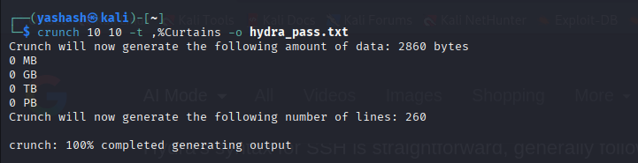
- Now run the hydra command to start brute force.
- hydra -l username -P /path/to/wordlist.txt ssh://192.168.56.102 -s 22222
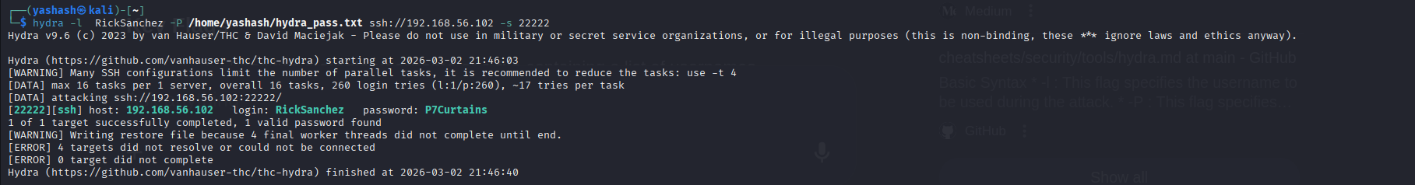
- we go the password(pw=P7Curtain)

- Finding the Root flag:
- Log in with the Rick user credentials
- Run ssh -p 22222 RickSanchez@192.168.56.102
- After log in check for what all the access u have(previliges)
- Sudo -l (checks for the previliges)
- If he password that we entered(Rick pass) is correct then we can say that Rick is a sudo user.
- From the above it says that Rick has all the access and can use all commands.
- We can switch the user to root , by the command sudo -i
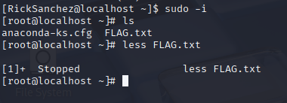
- Read the file and get the flag
